LuxSenz receiver assembly manual

# Required tools

* 3D printer
* Solder tools
* Drill

# Part list

* LuxSenz PCB
* Waveshare 2.9 inch e-Paper
* ST-Link V2 STM32 programmer
* Dupont wires to connect batteries or the STM32 programmer
* 8-pin JST connector cable to connect the e-Paper (2.00mm pitch to 2.54mm pitch, if the e-Paper has a 2.00mm connector)
* 25mm diameter lens
* 110x60mm solar panel
* Aluminium PCB case 50x25x25 mm
* Copper foil tape 25x110mm (or a roll of 25mm copper foil tape)
* 2x TP4056 module board
* ~~Flat Li-Ion battery 3.7V, at least 200 mAh, maximum size 57x67x4mm, with protection circuit~~
* 2x Flat Li-Ion battery 3.7V 1200 mAh, maximum size 57x67x4mm, with protection circuit
* STM32L031K6T6 LQFP-32 microcontroller
* ABS07-120-32.768k oscillator crystal
* TEPT4400 phototransistor
* MCP3201 SOIC-8 ADC
* 2x OPA2325 dual-opamp SOIC-8
* TLE2425ID, SOIC-8 reference voltage
* AMS1117-3.3V SOT223-3 voltage regulator
* 1x40 pins pin header 2.54mm
* 2x MCP4012 50kOhm SOT-23-6
* 2x Aluminium electrolytic capacitor radial can 4x5.4mm 10uF
* 8x MLCC capacitor SMD 0603 1uF
* 9x MLCC capacitor SMD 0603 100nF
* 1x MLCC capacitor SMD 0603 10uF
* 2x MLCC capacitor SMD 0603 7pF
* 2x resistor SMD 0603 100Ohm
* 7x resistor SMD 0603 1.5kOhm
* 2x resistor SMD 0603 2.2kOhm ?
* 1x resistor SMD 0603 10kOhm
* 1x resistor SMD 0603 68kOhm
* 2x resistor SMD 0603 47kOhm optional
* 1x inductor SMD 0603 10uHPCB Assembly

# Casing

Use a 3D-printer to print receiver_case once and receiver_block_lens_25mm twice. This will take a few hours and in the meantime, other parts can be assembled.

Use screws to assemble the aluminium PCB box (leave the top side of the box open). Use drilling tools to drill a hole with diameter between 5 mm and 7 mm in the aluminium PCB box according to the dimensions in the picture below. When the assembled PCB is slid into the aluminium box, the hole should be straight in front of the phototransistor (right picture, with assembled PCB placed into the box).

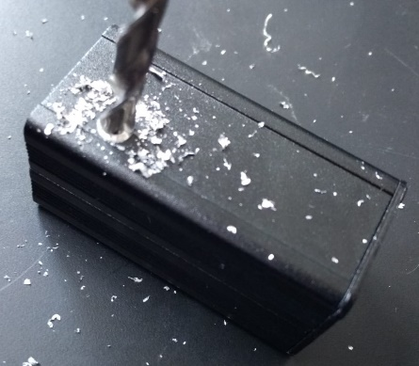 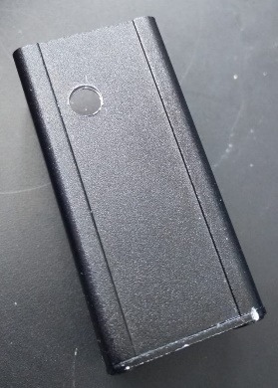 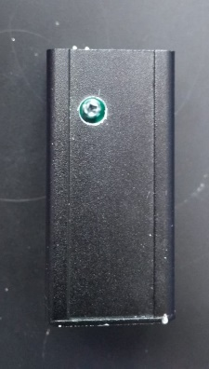

40mm

9mm

Stick a piece of copper tape around it. Scratch the tape away at the hole in the box. The gap will let light pass towards the sensor.

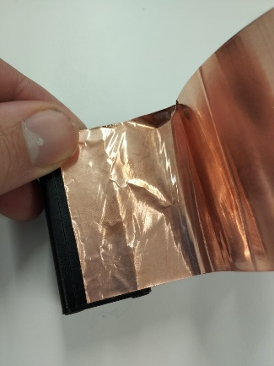 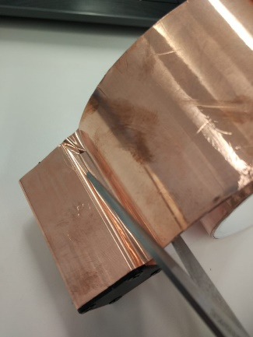 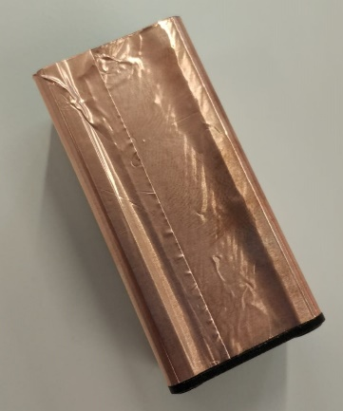 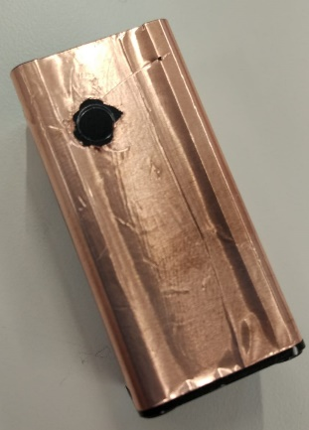

Soldering the PCB

Solder parts on the PCB according to the PCB design (3D model). Take into account the following design errors and their solutions:

* For U1 (AMS-1117-3.3V), do not place the part normally on the PCB, but solder it on the pads while maximizing the distance to the edge of the PCB. If this part is placed centred on the pads, the PCB does not fit into the aluminium casing.
* For J3 (connection header to e-ink display): Default Dupont cables do not fit in the aluminium casing. Make sure a JST-2.54mm connector is available to connect the e-ink display.

# Soldering of connecting wires

Solder wires from the solar to the input pads of both TP4056 modules. The solar panel’s – pole should be connected to both IN– pads, and the solar panel’s + pole should be connected to both IN+ pads. The IN– pads are internally connected to ground (and output BAT–). There should be no other interconnection between the analogue and digital ground input pins of the PCB. Put some isolating tape or hot glue around the connection pads around the centre of the solar panel, to prevent short circuits from any other connection pin or wire.

For both TP4056 modules, connect one of the Li-Ion batteries to the battery connectors BAT– and BAT+. Split all connecting wires and connect a 4-pin Dupont connector with the following pinout: 1 (yellow) BAT1-, 2 (white) BAT1+, 3 (black) BAT2-, 4 (red) BAT2+. Make sure no short circuits are made during soldering. The connections between batteries, charger modules and solar panel should look as below.

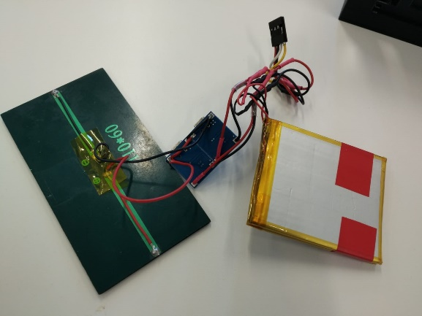 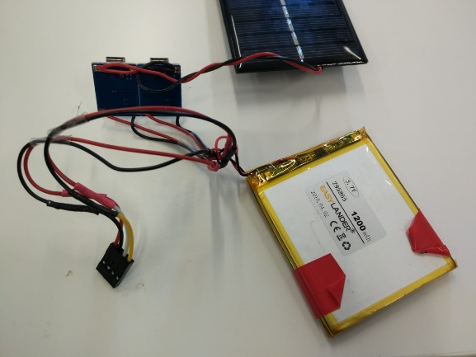

Solder a short (ca. 2cm) wire on the copper shielding tape, above the hole that was drilled before. Solder the other end to one (yellow) wire of a 4-wire (yellow-white-black-red) Dupont cable: the wire that will connect the analogue ground input. One end of the Dupont cable may be split into 2+2 connectors when the first version of the Receiver PCB is used, such that it can connect to both input connectors.

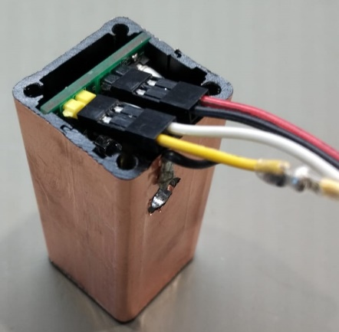 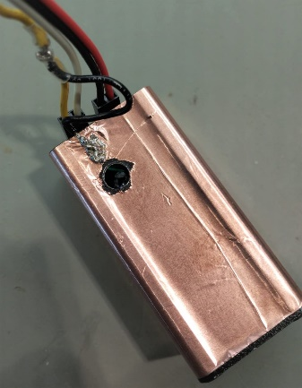

# Putting everything together

When all soldering and 3D-printing has finished, everything can be put together. The lens will fit into the holder that was printed in two pieces.

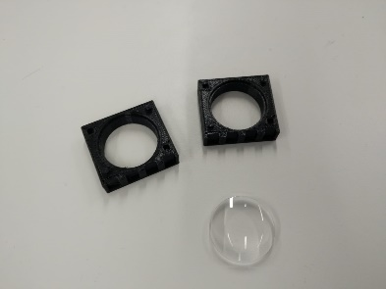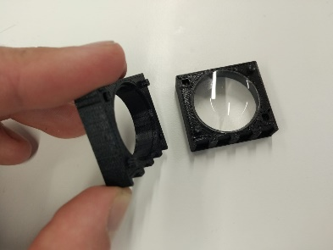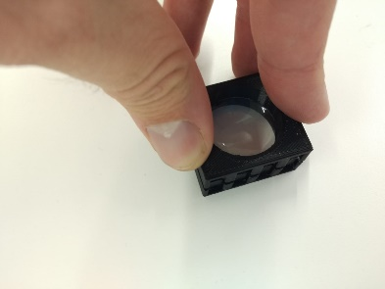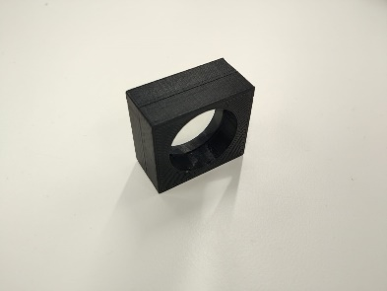

The lens piece can be shifted into the front of the casing. The battery and charging modules can find their place on the side.

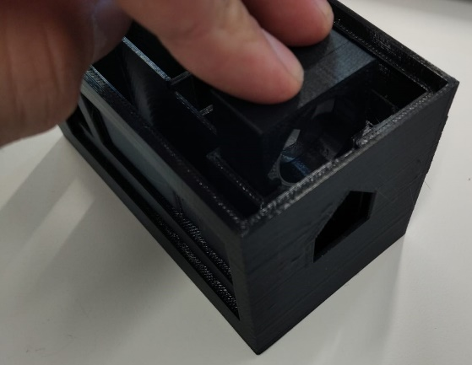 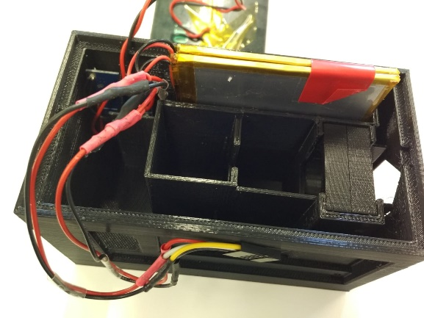

The wires between the e-ink display and the PCB should go through the gap on the side of the casing. Both ends can be connected, then the e-ink display can be fit into the outline on the same side as the gap.

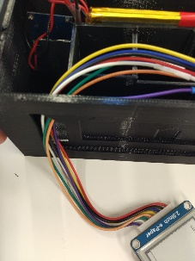 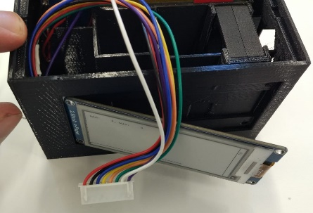 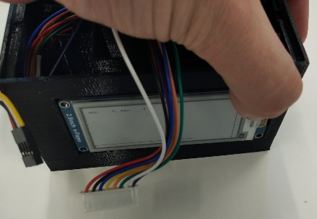 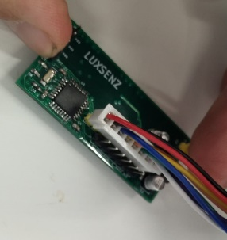

The PCB can be shifted into the aluminium box and put into its position in the casing. Connect the Dupont wires correctly to the voltage inputs of the PCB: the Analog ground input should be connected to the copper shielding.

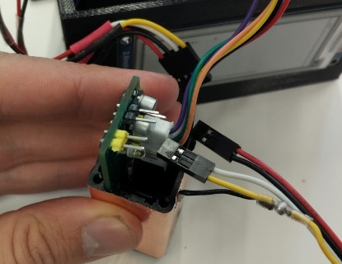 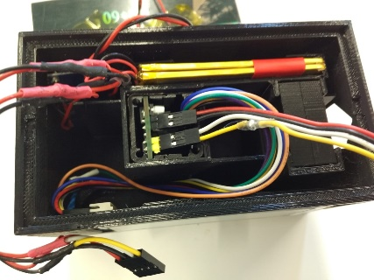 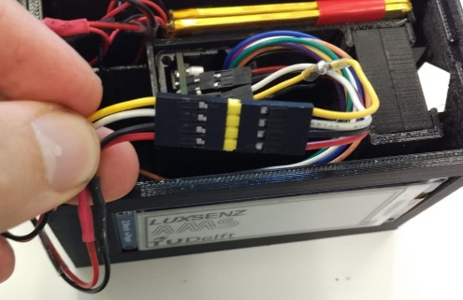

# Close the box

The casing can be closed by putting the solar panel on the top side. It should have a tight fit.

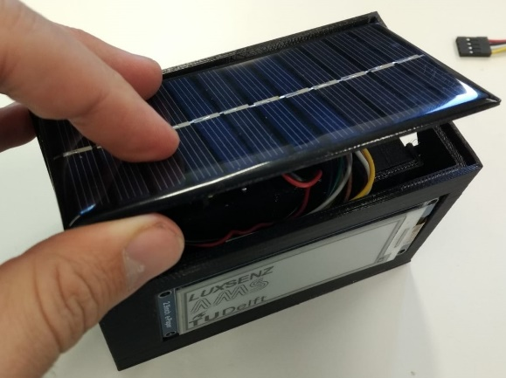 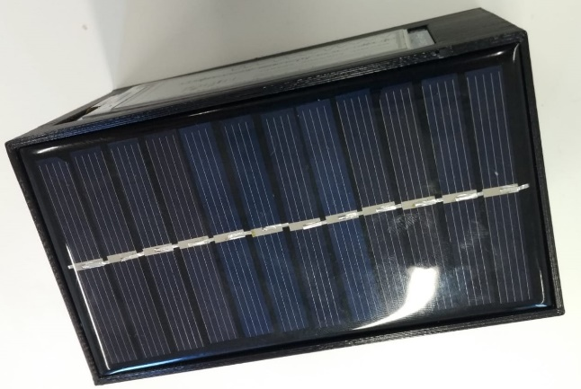

# Programming

The microcontroller can be programmed using an ST-LINK V2-programmer. Disconnect the power wires from the USB and connect the pins 3V3, SWCK, G, SWIO to the pints 3.3V, SWCLK, GND, SWDIO of the programmer. Run your favourite software to program the LuxSenz software on the board. Disconnect the programmer and reconnect the power wires.

# Changing LuxSenz software

Altering the software to change the functionalities of the receiver can be challenging, because the resources on the microcontroller are limited.

* VisualGDB shows details about memory consumption, but thinks there is more SRAM available than in reality. Computed FLASH usage is correct (compiler will throw errors, if too much FLASH is required).

## Correcting clock frequency

Before setting up a communication channel, one must ensure that the sample frequency of the receiver is correct. See the section *Correcting the sample frequency* in the document *LuxSenz receiver software*.